ContactManagement_Verify Contact notes _Instance44_12-Jul-2018_03-16-26_AM_SingleSignOn.png

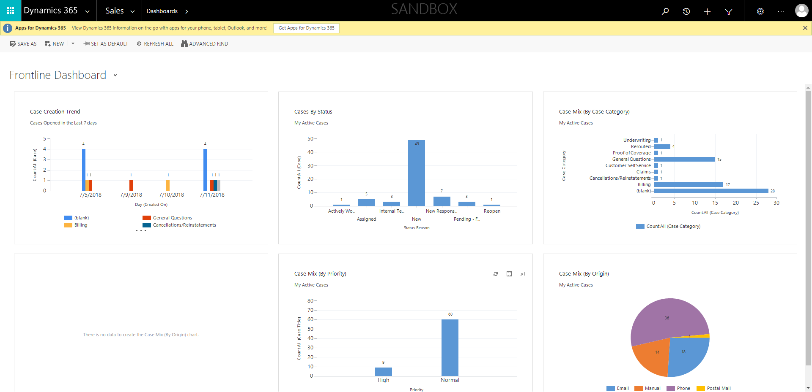

ContactManagement_Verify Contact notes _Instance44_12-Jul-2018_03-16-22_AM_SingleSignOn.png

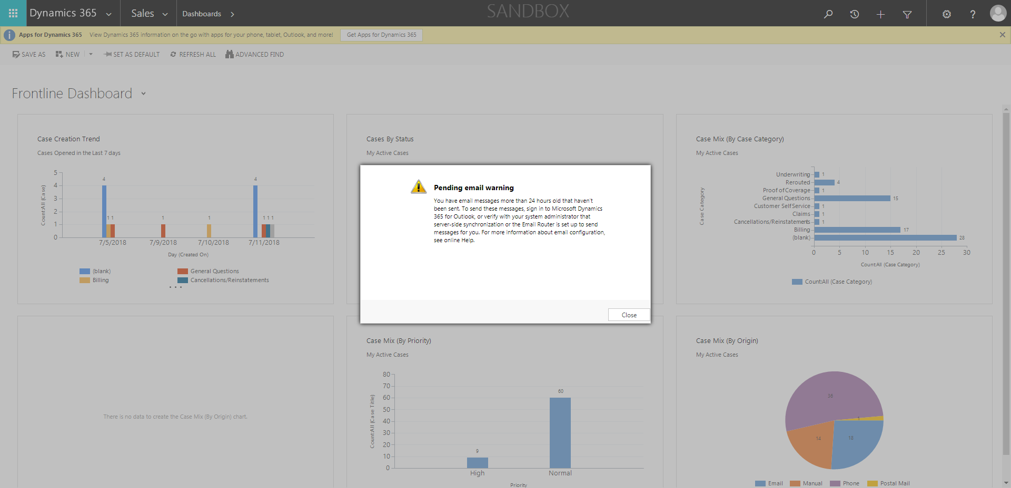

ContactManagement_Verify Contact notes _Instance44_12-Jul-2018_03-15-48_AM_MouseClickActiononStaleElement.png

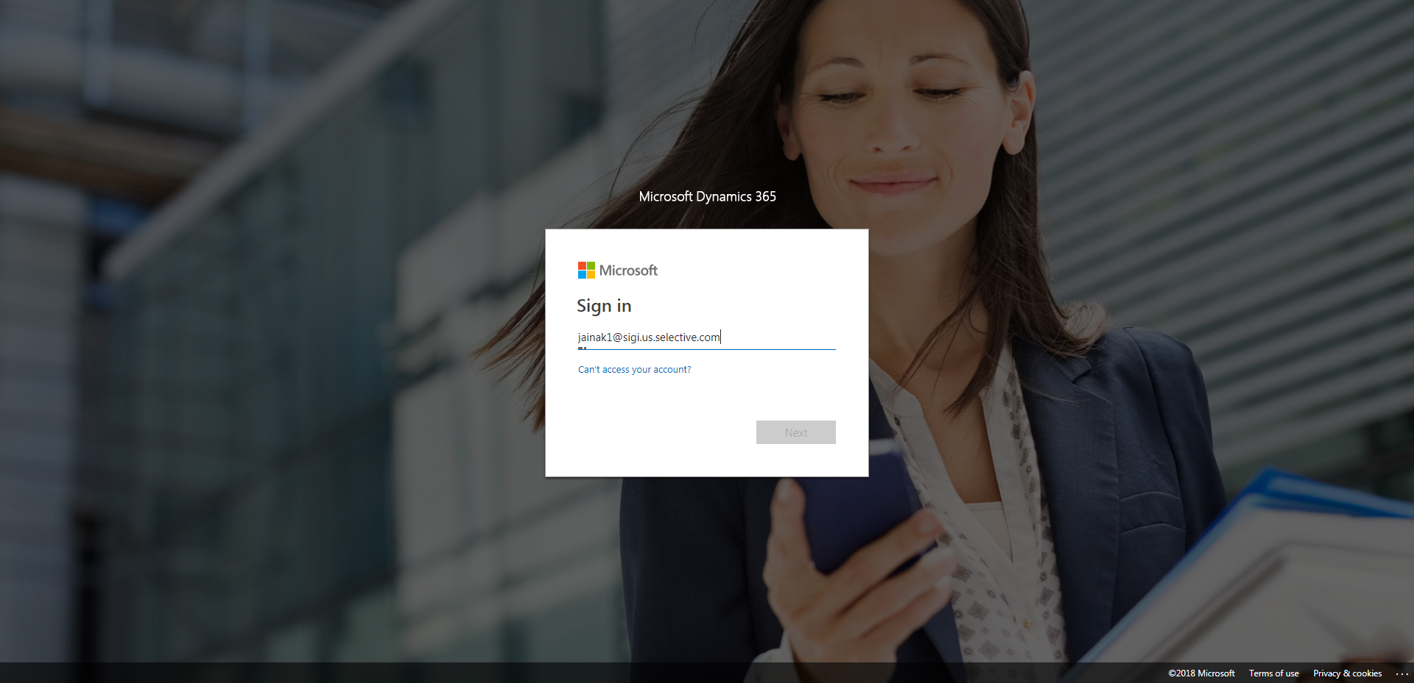

ContactManagement_Verify Contact notes _Instance44_12-Jul-2018_03-17-48_AM_VerifyingAllNotesofanindividual.png

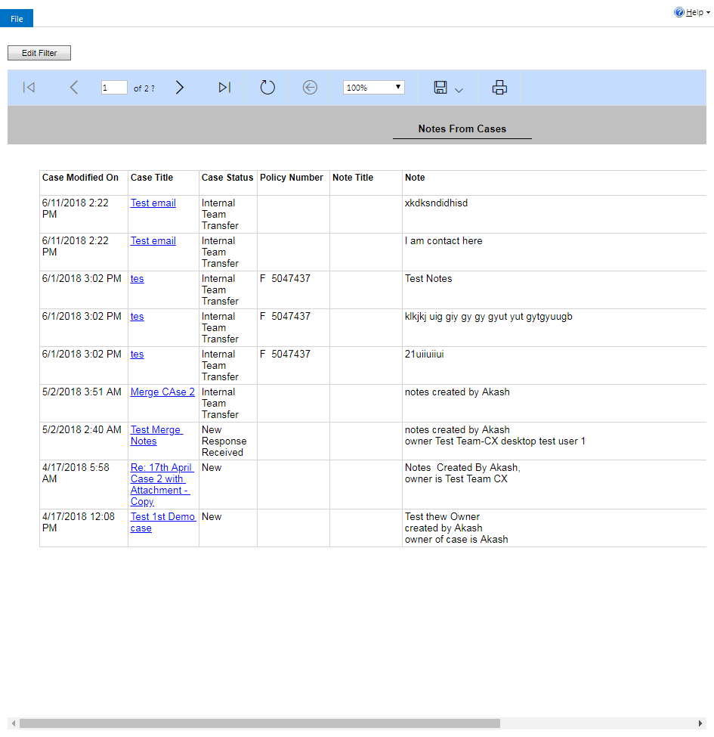

ContactManagement_Verify Contact notes _Instance44_12-Jul-2018_03-17-31_AM_Validatingcontactentitynavigation.png

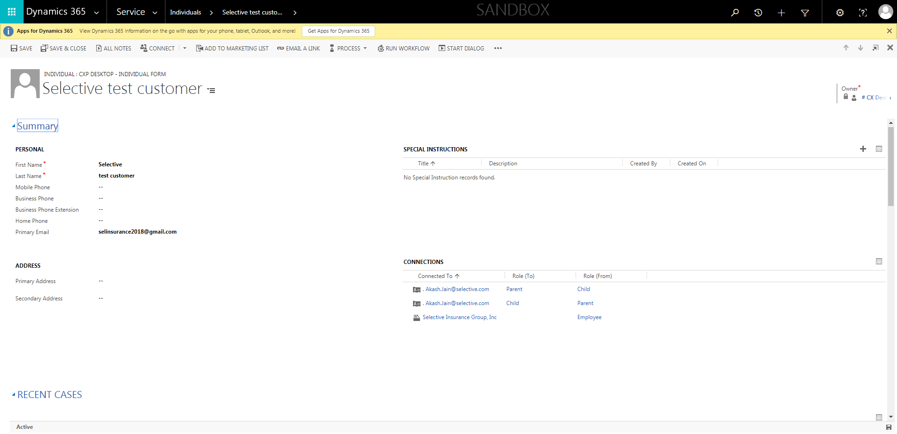

ContactManagement_Verify Contact notes _Instance44_12-Jul-2018_03-15-47_AM_EnterTextAction.png

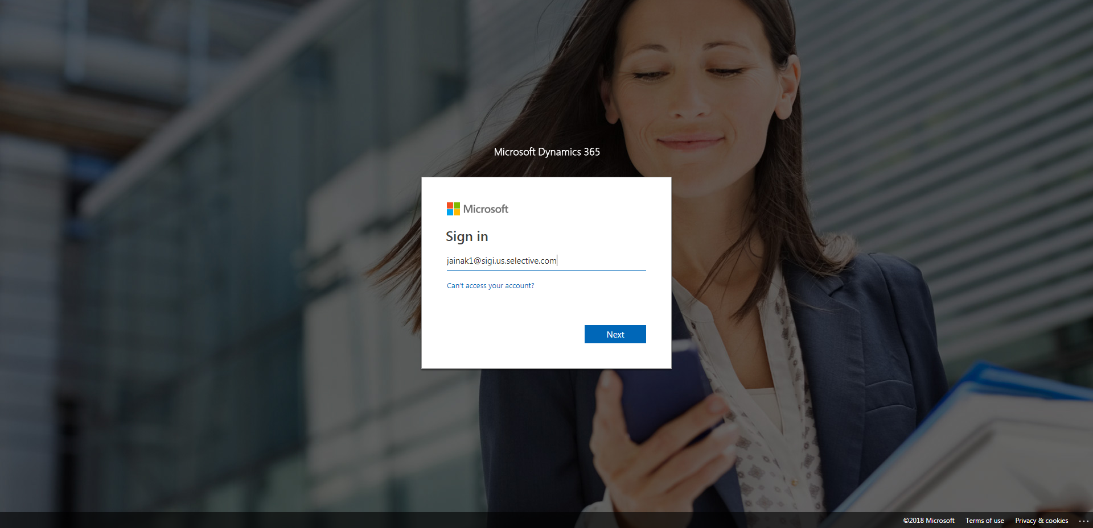

ContactManagement_Verify Contact notes _Instance44_12-Jul-2018_03-15-45_AM_MouseClickActiononStaleElement.png

